3/6/2025

Riphah International University

**Name:** Ayesha Tayyaba

**SAPID**: 56546

**Department:** CS

Lab Number: 04

COAL

**CODE:01**

org 100h

.MODEL SMALL

.STACK 100H

.DATA

.CODE

MAIN PROC

MOV DL,'5'

MOV AH,2

INT 21H

MOV DL,'6'

MOV AH,2

INT 21H

MOV DL,'5'

MOV AH,2

INT 21H

MOV DL,'4'

MOV AH,2

INT 21H

MOV DL,'6'

MOV AH,2

INT 21H

MAIN ENDP

END MAIN

**OUTPUT:**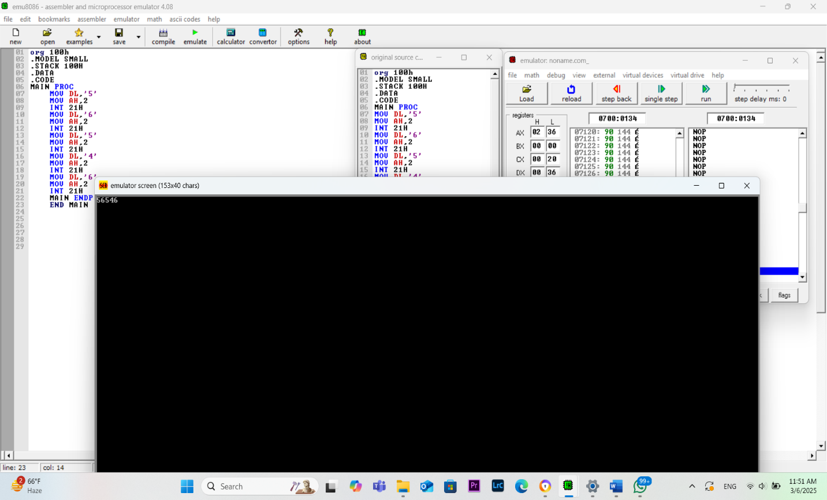

**CODE: 02**

.model small

.stack 100h

.data

prompt1 db 'Enter first number: $'

prompt2 db 'Enter second number: $'

result_msg db 'The sum is: $'

newline db 0x0A, 0x0D, '$'

num1 db 0

num2 db 0

sum db 0

.code

main:

mov ax, @data

mov ds, ax

lea dx, prompt1

mov ah, 09h

int 21h

call GetFirstInput

mov bl, num1

lea dx, prompt2

mov ah, 09h

int 21h

call GetSecondInput

mov al, num2

sub bl, 30h

sub al, 30h

add al, bl

add al, 30h

mov sum, al

lea dx, result_msg

mov ah, 09h

int 21h

mov dl, sum

mov ah, 02h

int 21h

lea dx, newline

mov ah, 09h

int 21h

mov ah, 4Ch

int 21h

GetFirstInput proc

mov ah, 01h

int 21h

mov num1, al

ret

GetFirstInput endp

GetSecondInput proc

mov ah, 01h

int 21h

mov num2, al

ret

GetSecondInput endp

end main

**OUTPUT:**

